**Summer Training Report**

**ATM MACHINE**

**A Project Report/Synopsis submitted in partial fulfilment of**

**the requirements for the award of**

**Bachelor in Engineering**

**IN**

**COMPUTER SCIENCE AND ENGINEERING**

**Submitted by**

**Priyadarshini**

**(Roll no: LCO17373)**

**Under the supervision of**

**Saurabh Kaushal**

**Student Centre,**

**NITTTR,**

**Sector 26, 160019,**

**Chandigarh**



**CHANDIGARH COLLEGE OF ENGINEERING AND TECHNOLOGY**

**(DEGREE WING)**

Government Institute under Chandigarh (UT) Administration, Affiliated to Panjab University, Chandigarh

Sector-26, Chandigarh. PIN-160019

**June, 2019**

**CHANDIGARH COLLEGE OF ENGINEERING AND TECHNOLOGY (DEGREE WING)**

Government Institute under Chandigarh (UT) Administration | Affiliated to Panjab University , Chandigarh

Sector-26, Chandigarh. PIN-160019 | Tel. No. 0172-2750947, 2750943 Website: [www.ccet.ac.in](http://www.ccet.ac.in/) | Email: [principal@ccet.ac.in](mailto:principal@ccet.ac.in) | Fax. No**. :**0172-2750872



**Department of Computer Sc. & Engineering**



**CANDIDATE’S DECLARATION**

I hereby declare that the work presented in this report entitled “**ATM Machine”**, in fulfilment of the requirement for the award of the degree Bachelor of Engineering in Computer Science & Engineering, submitted in CSE Department, Chandigarh College of Engineering & Technology (Degree wing) affiliated to Punjab University, Chandigarh, is an authentic record of my/our own work carried out during my degree under the guidance of **Saurabh Kaushal**. The work reported in this has not been submitted by me for award of any other degree or diploma.

Date: 8th July, 2019

Place: Chandigarh

Name: Priyadarshini

Roll No.: LCO17373



**CHANDIGARH COLLEGE OF ENGINEERING AND TECHNOLOGY (DEGREE WING)**

Government Institute under Chandigarh (UT) Administration | Affiliated to Panjab University , Chandigarh

Sector-26, Chandigarh. PIN-160019 | Tel. No. 0172-2750947, 2750943 Website: [www.ccet.ac.in](http://www.ccet.ac.in/) | Email: [principal@ccet.ac.in](mailto:principal@ccet.ac.in) | Fax. No**. :**0172-2750872



**Department of Computer Sc. & Engineering**



**CERTIFICATE**

This is to certify that the Project work entitled “**ATM MACHINE**” submitted by **Priyadarshini, LC017373** in fulfilment for the requirements of the award of Bachelor of Engineering Degree in Computer Science & Engineering at Chandigarh College of Engineering and Technology (Degree Wing), Chandigarh is an authentic work carried out by him/her under my supervision and guidance.

To the best of my knowledge, the matter embodied in the project has not been submitted to any other University / Institute for the award of any Degree.

Date: 8th July, 2019

Place: Chandigarh

Saurabh Kaushal

Relearn Academy,

Student Centre,

NITTTR,

Chandigarh



**CHANDIGARH COLLEGE OF ENGINEERING AND TECHNOLOGY (DEGREE WING)**

Government Institute under Chandigarh (UT) Administration | Affiliated to Panjab University , Chandigarh

Sector-26, Chandigarh. PIN-160019 | Tel. No. 0172-2750947, 2750943 Website: [www.ccet.ac.in](http://www.ccet.ac.in/) | Email: [principal@ccet.ac.in](mailto:principal@ccet.ac.in) | Fax. No**. :**0172-2750872



**Department of Computer Sc. & Engineering**



**ACKNOWLEDGEMENT**

I would like to express my sincere gratitude to my mentor Mr. Saurabh Kaushal and team for guiding and helping me throughout my trainee period from 7th June – 12th July, 2019. I was introduced to Python Programming; it was a good learning experience under him. I would like to thank them for sharing their valuable knowledge and time.

I would also express my thank you towards Mr. Saurabh Kaushal for his constant support in resolving all my doubts with outmost patience.

I want to acknowledge my sincerest gratitude to all those who assisted and guided me in completing this project report and making my summer training a memorable and successful experience.

**LIST OF FIGURES**

|  | **FIGURES/ DESCRIPTION** | **PAGE NO.** |
| --- | --- | --- |
|  | |  |
| 1: Flowchart | | 10 |
| 2: Welcome window | | 11 |
|  | |  |
| 3: Login window | | 11 |
|  | |  |
| 4: Verifying the email | | 12 |
|  | |  |
| 5: OTP Verification | | 12 |
|  | |  |
| 6: Choices | | 13 |
|  | |  |
| 7: Balance Enquiry | | 13 |
|  | |  |

**TABLE OF CONTENTS**

| **SR. NO.** | **TOPIC** | **PAGE NO.** |  |
| --- | --- | --- | --- |
|  |  |  |  |
| 1 | Declaration | 1 |  |
|  |  |  |  |
| 2 | Acknowledgement | 2 |  |
|  |  |  |  |
| 3 | Certificate | 3 |  |
|  |  |  |  |
| 4 | List of figures | 4 |  |
|  |  |  |  |
| 5 | List of tables | 5 |  |
|  |  |  |  |
| 6 | Chapter - 1 | 6 |  |
| Introduction |  |
|  |  |  |
|  |  |  |  |
| 7 | Chapter - 2 | 7 |  |
| Literature review |  |
|  |  |  |
|  |  |  |  |
| 8 | Chapter - 3 | 8 |  |
| Designing |  |
|  |  |  |
|  |  |  |  |
| 9 | Chapter - 4Coding and Testing | 9 |  |
| 10 | Chapter - 5Conclusion and future scope | 18 |  |
| 11 | Bibliography | 19 |  |
|  |  |  |  |

**CHAPTER 1**

**INTRODUCTION**

**Introduction to ATM Machine: -**

An **automated teller machine** (**ATM**) is an electronic telecommunications device that enables customers of [financial institutions](https://en.wikipedia.org/wiki/Financial_institution) to perform [financial transactions](https://en.wikipedia.org/wiki/Financial_transaction), such as cash withdrawals, deposits, transfer funds, or obtaining account information, at any time and without the need for direct interaction with bank staff.

It is an electronic device which is used by only bank customers to process account transactions. The users access their account through a special type of plastic card that is encoded with user information on a magnetic strip.

The strip contains an identification code that is transmitted to the bank’s central computer by modem. The users insert the card into ATMs to access the account and process their account transactions. The automated teller machine was invented by john shepherd-Barron in year of 1960

## **Software Requirements:**

* Windows 8.1
* Python ( Jupyter Notebook)
* Wamp Server

## **Hardware Components:**

* + Processor
  + Hard Disk
  + Memory

**CHAPTER-2**

# **Literature review**

In modern days money withdrawal via ATM (Automated Teller Machine) is becoming a main part of our life. This paper provides the brief description of ATM system. It also explains the issues of ATM system. The security requirements of the ATM system are discussed. The problem of misusing the information related to the customer in ATM system is addressed.

ATMs does not require any person performing the transaction to present his picture identification such as sign and his physical presence. If the bank card is stolen by the criminal and the PIN number is known, a criminal person can easily make an access to the bank account. There has also been lot of incidents of criminal by the Man-in-the-middle attacks, where criminals have attached card readers or fake keypads to the existing ATM machines.

These fake keypads will be used to read customers' PINs and transaction password in order to make unauthorized access to the bank customers. II. WORKING MECHANISM ATM is device which will be used for the getting the cash without the absence of bank clerk or employer. The customer will be identified by a smart card which contains 16 digit card numbers.

When the customer inserts the card inside the ATM machine card number will be read and it will ask the customer for a secret PIN and the amount to be debited. The card number and secret PIN will be encrypted and send to the server. At the server side the card number and secret PIN will be decrypted and if all the details matched with the particular customer then the customer is said to be authentic otherwise the transaction will be debited.

**FLOW CHART OF ATM MACHINE**

**Designing:**

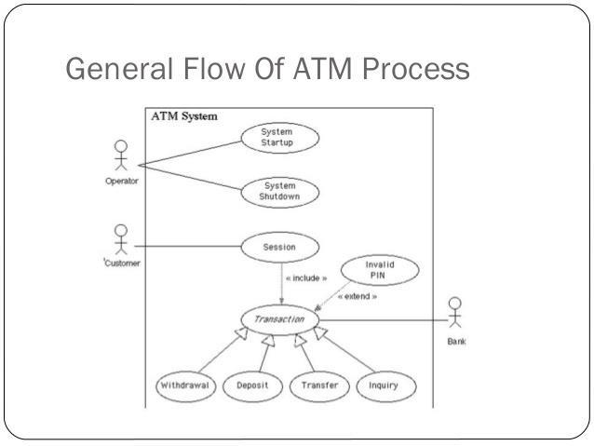

**Python:**

**CHAPTER- Coding**

[**Python**](https://www.geeksforgeeks.org/python-programming-language/) is a widely used general-purpose, high level programming language. It was initially designed by Guido van Rossum in 1991 and developed by Python Software Foundation.

It was mainly developed for emphasis on code readability, and its syntax allows programmers to express concepts in fewer lines of code.

Python is a programming language that lets you work quickly and integrate systems more efficiently.

There are two major Python versions- **Python 2 and Python 3**. Both are quite different.

Python is [dynamically typed](https://en.wikipedia.org/wiki/Dynamic_programming_language) and [garbage-collected.](https://en.wikipedia.org/wiki/Garbage_collection_(computer_science)) It supports multiple [programming](https://en.wikipedia.org/wiki/Programming_paradigms) [paradigms,](https://en.wikipedia.org/wiki/Programming_paradigms) including [procedural,](https://en.wikipedia.org/wiki/Procedural_programming) object-oriented, and [functional programming](https://en.wikipedia.org/wiki/Functional_programming). Python is often described as a "batteries included" language due to its comprehensive [standard library](https://en.wikipedia.org/wiki/Standard_library).



# **Applications of Python in the Real World**

Python is a high-level general purpose programming language that offers multiple paradigms like object-orientation, and structural and functional programming for software development

# **Applications of Python**

1. **GUI-Based Desktop Applications:**

Python has simple syntax, modular architecture, rich text processing tools and the ability to work on multiple operating systems which make it a desirable choice for developing desktop-based applications.

**Image Processing and Graphic Design Applications:**

Python has been used to make 2D imaging software such as Inkscape, GIMP, Paint Shop Pro and Scribes. Further, 3D animation packages, like Blender, 3ds Max, Cinema 4D, Houdini, Lightwave and Maya, also use Python in variable proportions.

**Games:**

Python has various modules, libraries and platforms that support development of games. For example, PySoy is a 3D game engine supporting Python 3, and PyGame provides functionality and a library for game development..

1. **Web Frameworks and Web Applications:**

Python has been used to create a variety of web-frameworks including CherryPy Django, TurboGears, Bottle, Flask etc. These frameworks provide standard libraries and modules which simplify tasks related to content management, interaction with database and interfacing with different internet protocols such as HTTP, SMTP, XML-RPC, FTP and POP.

## **Enterprise and Business Applications:**

With features that include special libraries, extensibility, scalability and easily readable syntax, Python is a suitable coding language for customizing larger applications.

## **Operating Systems:**

Python is often an integral part of Linux distributions. For instance, Ubuntu’s Ubiquity Installer, and Fedora’s and Red Hat Enterprise Linux’s Anaconda Installer are written in Python. Gentoo Linux makes use of Python for Portage, its package management system.

## **Language Development:**

Python’s design and module architecture has influenced development of numerous languages. Boo language uses an object model, syntax and indentation, similar to Python. Further, syntax of languages like Apple’s Swift, CoffeeScript, Cobra, and OCaml all share similarity with Python.

# **Benefits of Python Programming Language**

* + **Interpreted language:** the language is processed by the interpreter at runtime, like [PHP](https://www.educba.com/course/php-mysql-for-beginners/) or [PERL](https://www.educba.com/course/perl-programming-training-course/), so you don’t have to compile the program before execution.
  + **Interactive:** you can directly interact with the interpreter at the Python prompt for writing your program.
  + **Perfect for beginners**: for beginner-level programmers, Python is a great choice as it supports the development of applications ranging from games to browsers to text processing.

# **SQL and WampServer**

**SQL** is a database computer language designed for the retrieval and management of data in a relational database.

**SQL** stands for **Structured Query Language**. This tutorial will give you a quick start to SQL. It covers most of the topics required for a basic understanding of SQL and to get a feel of how it works

SQL is Structured Query Language, which is a computer language for storing, manipulating and retrieving data stored in a relational database.

SQL is the standard language for Relational Database System. All the Relational Database Management Systems (RDMS) like MySQL, MS Access, Oracle, Sybase, Informix, Postgres and SQL Server use SQL as their standard database language.

**WampServer** is a Windows web development environment. It allows you to create web applications with Apache, PHP and the MySQL database. It also comes with PHPMyAdmin to easily manage your databases.

**Wamp** stands for **W**indows/**A**pache/**M**ySQL/**P**HP, **P**ython, (and/or) **P**ERL

The acronym WAMP refers to a set of free ([open source](https://www.webopedia.com/TERM/O/open_source.html)) [applications](https://www.webopedia.com/TERM/A/application.html), combined with Microsoft Windows, which are commonly used in [Web server](https://www.webopedia.com/TERM/W/Web_server.html) environments. The WAMP stack provides developers with the four key elements of a Web server: an [operating system](https://www.webopedia.com/TERM/O/operating_system.html), [database,](https://www.webopedia.com/TERM/D/database.html) Web server and Web scripting software

## **Application of SQL**

As mentioned before, SQL is one of the most widely used query language over the databases. I'm going to list few of them here:

* + - Allows users to access data in the relational database management systems.
    - Allows users to describe the data.
    - Allows users to define the data in a database and manipulate that data.
    - Allows to embed within other languages using SQL modules, libraries & pre-compilers.
    - Allows users to create and drop databases and tables.
    - Allows users to create view, stored procedure, functions in a database.
    - Allows users to set permissions on tables, procedures and views

# **Testing:**

**Welcome Window:**

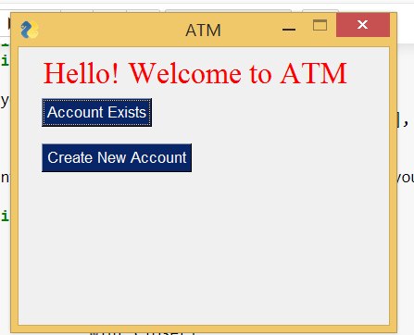

## **Login window:**

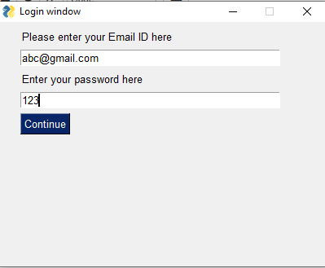

**Verifying the email:**

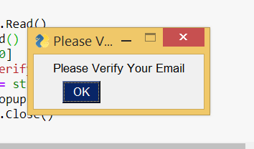

**OTP Verification:**

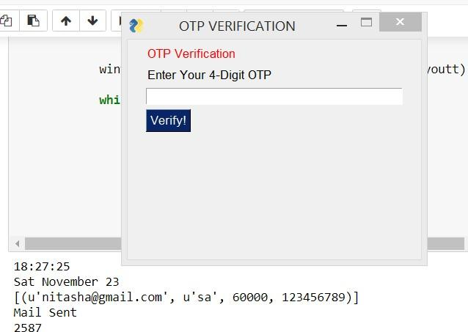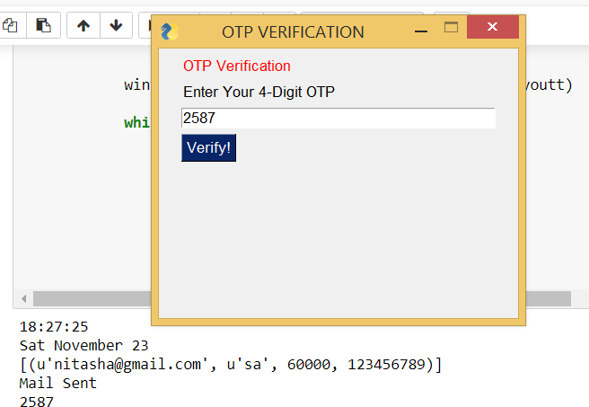

**Choices:**

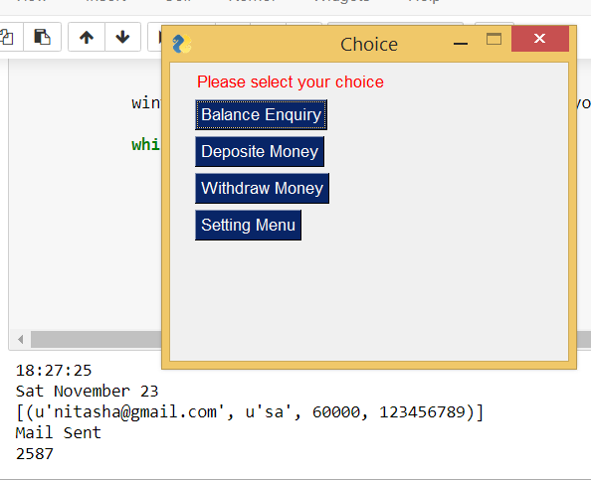

**Balance Enquiry:**

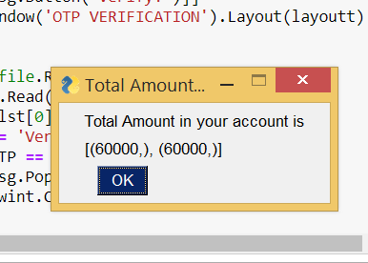

**Conclusion and future scope:**

ATMs are a convenience to consumers needing quick access to cash, and businesses that carry the machines, such as stores and restaurants, are frequently the first place that money is spent.

This project shows us the features of ATM i.e. Balance Enquiry, Deposit Money, Withdraw Money, and Settings Menu.

Setting menu consist of mail change feature.

This project helps to know more about the ATM machine.

Generally, we have seen that **Python programming language is extensively used for web development, application development, system administration, developing games etc.**

**1) Artificial Intelligence (AI)**

**Python programming language is undoubtedly dominating the other languages when future technologies like Artificial Intelligence(AI) comes into the play.**

It is only the Artificial Intelligence that has made it possible to develop speech recognition system, autonomous cars, interpreting data like images, videos etc.

## **Big Data**:

The future scope of python programming language can also be predicted by the way it has helped big data technology to grow. Python has been successfully contributing in analyzing a large number of data sets across computer clusters through its high-performance toolkits and libraries.

## **Networking**

Networking is another field in which python has a brighter scope in the future. Python programming language is used to read, write and configure routers and switches and perform other networking automation tasks in a cost-effective and secure manner.

# **Bibliography**

* 1. https://en.wikipedia.org/wiki/Automated_teller_machine
  2. htt[ps://www.gr8ambition](http://www.gr8ambitionz.com/2013/09/automated-teller-machine-atm.html)z[.com/2013/09/automated-teller-machine-atm.html](http://www.gr8ambitionz.com/2013/09/automated-teller-machine-atm.html)
  3. [www.sql-tutorial.com/sql-introduction-sql-tutorial/](http://www.sql-tutorial.com/sql-introduction-sql-tutorial/)